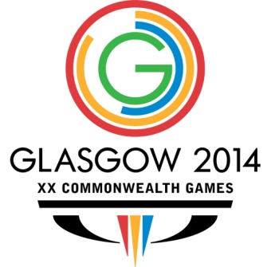

**Indian Shuttlers reach Semifinals of Mixed Team Event at CWG**

July 27, 2014, 04:11 PTI

**Glasgow:** P V Sindhu suffered a three-game loss against Michelle Li in the Women`s Singles but the Indian Badminton Team still managed to advance to the Semifinals of the Mixed Team Championship after defeating Canada 3-1 at the 20th Commonwealth Games, here.

Silver Medalists at the 2010 Delhi Games, India were leading 2-0 after the first two matches, courtesy the winning start by Mixed Doubles combo of Kidambi Srikanth and Jwala Gutta and Men`s Singles player Parupalli Kashyap.

However, Hong Kong-born Michelle then stunned Sindhu 15-21 22-20 21-17 in an hour-long Women`s Singles match to reduce the margin.

But Men`s Doubles pair of Pranaav Chopra and Akshay Dewalkar made sure there are no more hiccups as they notched up a 21-15 19-21 21-13 win over Adrian Liu and Derrick Ng in a 49-minute match.

Earlier, Srikanth and Jwala put India 1-0 ahead with a 21-19 17-21 21-18 win over Toby Ng and Alex Bruce in the Mixed Doubles match.

Ace shuttler Parupalli Kashyap then thrashed Andrew D`Souza 21-11 21-9 in a Men`s Singles match that last 28 minutes to make it 2-0 in India`s favour.

----------------------------------